Programming for the Web 1

Data transmission using the web

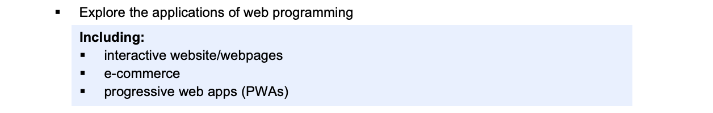
Explore the applications of web programming

Interactive website web pages
Definition
- An interactive webpage is a website that allows users to engage and interact with the content in real-time, rather than passively viewing static information.
- This interaction often involves actions like clicking buttons, filling out forms, dragging and dropping elements, or responding to prompts that trigger changes on the page.
- These changes could be anything from displaying new content to updating visual elements without needing to reload the entire page.

Key Features
- Dynamic User Input: Users can input information (e.g., filling forms, selecting preferences) and receive immediate feedback.
- Real-Time Updates: Content can change dynamically based on user interaction (e.g., updating product prices as users select different options).
- Interactive Media: Users can play with elements such as images, videos, and games that respond to clicks or other forms of input.
- Animations and Transitions: Movement and changes on the page, triggered by user interactions like hovering, clicking, or scrolling.
- Interactive Visualizations: Charts, graphs, and maps that allow users to filter or manipulate data visually.
- Real-Time Communication: Features like chatbots, live chat, or comment sections that update instantly.

Advantages
- Enhanced User Engagement: Interactive elements like buttons, forms, and quizzes capture users’ attention, encouraging them to stay longer and explore more, resulting in better engagement.
- Improved User Experience (UX): Users receive real-time feedback, such as form validation or dynamic product filtering, which makes the experience smoother, faster, and more personalized.
- Higher Conversion Rates: By guiding users through interactive steps or offering personalized recommendations, interactive webpages help turn visitors into customers or leads more effectively.
- Increased Time on Site: Engaging features like videos, quizzes, or animations keep users on the website for longer, improving dwell time and decreasing bounce rates.
- Better Data Collection and Insights: Interactive pages collect valuable user data (such as preferences or feedback), which can be used for marketing, product improvements, or personalization strategies.
- SEO Benefits: Interactive content can lead to lower bounce rates and longer visit durations, both of which contribute to improved search engine rankings.

Examples
- Online Forms: Forms that validate input instantly or provide dynamic suggestions.
- E-commerce Stores: Interactive product galleries, shopping carts, and dynamic pricing calculators.
- Social Media Platforms: Real-time likes, comments, and content interactions.
- Interactive Maps: Google Maps, where users can zoom, search, and receive dynamic data.
- Games: Browser-based games that allow users to interact with gameplay elements directly on the webpage.

E commerce
Definition
- An e-commerce webpage is a website specifically designed to facilitate the buying and selling of products or services online.
- It allows users to browse products, view details, compare prices, and make purchases directly from the website.
- E-commerce pages often integrate features that provide a seamless shopping experience, such as shopping carts, payment gateways, product recommendations, and customer reviews.

Key Features
- Product Listings: Displays a catalogue of items available for sale, typically organized into categories. Includes product images, descriptions, prices, and ratings.
- Product Pages: Detailed pages for each product, featuring specifications, high-quality images, videos, pricing, availability, and sometimes user reviews.
- Search and Filter Functions: Allows users to search for specific products and filter results based on attributes like price, brand, size, colour, or other relevant options.
- Shopping Cart: A feature that lets users add selected products to a virtual cart for later checkout. Allows users to modify quantities, remove items, and view the total cost.
- Checkout Process: A secure, multi-step process where users review their cart, input shipping details, select a payment method, and complete the purchase. Payment gateways like PayPal, Stripe, or credit card processors are typically integrated.
- User Accounts: Enables users to create accounts, save personal information for future purchases, track orders, and view their purchase history.
- Security Features: Ensures data security, often through SSL encryption and secure payment options, to protect user information and payment details.

Advantages
- 24/7 Availability: Customers can shop anytime from any location.
- Wider Reach: Businesses can reach customers globally without needing physical stores.
- Convenience: Customers can compare products, read reviews, and purchase with a few clicks.
- Lower Operational Costs: Compared to running a physical store, operating an online store often requires less overhead.

Examples - Hmmmm….. now let me think
Progressive web apps (PWAs)
Definition
- A Progressive Web Page (commonly known as a Progressive Web App, or PWA) is a type of website that behaves and feels like a native mobile app but runs in a web browser.
- It leverages modern web technologies to offer an app-like experience, providing users with offline functionality, push notifications, and the ability to add the site to their home screen, just like native apps.
Key Features
- Responsive: PWAs are designed to work on any device (desktops, tablets, smartphones), adjusting seamlessly to different screen sizes.
- Offline Access: Thanks to Service Workers, PWAs can cache content and allow users to access certain features or previously viewed pages when they are offline or have limited connectivity.
- App-like Experience: PWAs mimic the look and feel of native mobile apps, including smooth transitions, animations, and gestures like swiping.
- Fast Loading Times: PWAs load quickly, even under poor network conditions, thanks to their use of caching, optimized assets, and pre-caching strategies.
- Secure (HTTPS): PWAs must be served over HTTPS to ensure data integrity and protect user privacy. This security layer is crucial for protecting sensitive data like login credentials and payment information.
- Automatic Updates: PWAs automatically update in the background whenever new content or features are available, ensuring users always have the latest version without manual updates.
Advantages
- Cross-platform compatibility: PWAs work across all major browsers and devices, whether it's Android, iOS, Windows, or macOS.
- Reduced Development Costs: Since PWAs are web-based, developers only need to maintain a single codebase, unlike native apps which require separate development for iOS and Android.
- Improved User Engagement: Features like offline access and push notifications keep users engaged, improving user retention.
- SEO Friendly: Unlike native apps, PWAs are indexed by search engines, making them discoverable through regular web searches.

Examples – Uber, Starbucks, Trivago, Spotify
Investigate and practise how data is transferred on the Internet

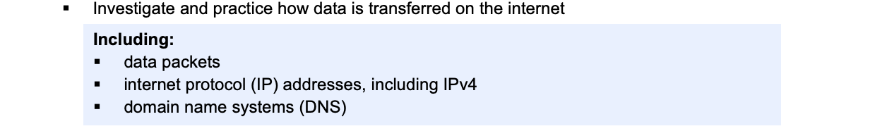

When data is sent over the internet, it is first broken down into smaller units called data packets. This process is essential because sending large amounts of data in one continuous stream can lead to inefficiencies, congestion, and possible loss of information. Breaking data into packets allows for better management of network traffic and ensures that large files can be transmitted quickly and reliably.
Each packet contains three key parts:
- Header: The header includes crucial information such as the source and destination IP addresses, the sequence number (to help reassemble packets in the correct order), and other metadata like error-checking information.
- Payload: This is the actual content of the data being transferred. For example, in the case of a webpage, the payload might include the text, images, or other media elements of that page.
- Trailer: Optional metadata that may include information for error checking, like checksums or CRC checks.
Once the data is broken into packets, these packets are sent individually across the network. They may take different routes to reach their destination, depending on factors such as network congestion or the availability of different paths. Routers—devices that direct packets to their destination—are responsible for deciding which path each packet will take.
At the destination, the packets are reassembled into their original form. This is done using the sequence numbers in the header to ensure that packets are placed in the correct order. If any packets are lost along the way, they can be requested again from the source.

The Transmission Control Protocol/Internet Protocol (TCP/IP) governs the entire process. The two key protocols here are:
- IP (Internet Protocol): Responsible for packet routing and addressing, making sure each packet reaches its intended destination.
- Each device connected to the internet has a unique identifier called an IP address. The most common version is IPv4, which uses a 32-bit address format, typically represented as four decimal numbers separated by periods (e.g., 192.168.1.1). This gives about 4.3 billion unique addresses, though many are reserved or not usable.
- TCP (Transmission Control Protocol): Ensures reliable data transfer by managing the assembly and error-checking of packets. It ensures all packets are received, reassembled in the correct order, and checked for errors.
The Domain Name System (DNS) is a fundamental component of the internet, enabling users to access websites using easily remembered domain names (like www.example.com) instead of numerical IP addresses (like 192.0.2.1).
When a user enters a domain name into their browser, a process known as DNS resolution begins. The DNS acts like a phonebook for the internet, translating human-readable domain names into the machine-readable IP addresses that computers use to communicate.
The process works as follows:
- The user's device sends a request to a DNS server asking for the IP address associated with the domain name.
- If the DNS server has the IP address in its cache, it returns the information immediately.
- If the IP address is not in the cache, the DNS server will query other DNS servers, working its way up through the hierarchy of DNS servers (such as root servers and top-level domain servers) until it finds the correct IP address.
- Once the IP address is found, it is returned to the user's device, which can then use the IP address to send data packets to the correct server.
This system allows users to access websites without needing to remember long and complex IP addresses, making the internet more user-friendly.

Investigate and describe the function of web protocols and the ports

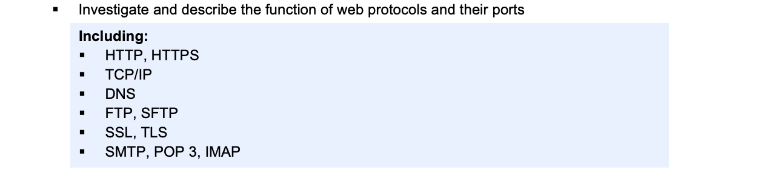

There are literally thousands of different protocols that exist. Each protocol is designed to specify a particular set of rules and accomplish particular tasks.
Before two devices can communicate they must first agree on the protocol or series of protocols they will utilise. This process is known as ‘handshaking’. Handshaking commences when one device asks to communicate with another; the devices then exchange messages until they have agreed upon the rules that will be used. Depending on the protocol being used handshaking may occur just after the devices are powered up or it may occur prior to each communication session occurring.
Web protocols are essential for facilitating communication between devices over the internet. Each protocol serves a specific purpose and operates on designated ports within the TCP/IP networking model. Understanding these protocols and their associated ports is crucial for managing network communication and ensuring secure and efficient data transfer over the Internet.
Ports are like different mailboxes at the post office. Each mailbox (port) is assigned a specific number, and different types of mail (data) go to different mailboxes. For example, letters might go to one mailbox, packages to another, and urgent mail to yet another. Similarly, on the internet, different types of data traffic use specific ports to ensure it goes to the right destination.
Ports are like virtual doors that allow different types of data to pass through a network. When you access a website using HTTPS, your browser communicates with the website's server through port 443 to establish a secure connection.

HTTP and HTTPS Protocols
- The HyperText Transfer Protocol (HTTP) and its secure version, HyperText Transfer Protocol Secure (HTTPS), are two fundamental web protocols responsible for enabling communication between a client (usually a web browser) and a server.
- HTTP is an application-layer protocol that facilitates the transmission of hypertext (such as HTML documents), images, videos, and other types of web resources between web browsers and servers. It is stateless, meaning that each HTTP request and response is independent of any previous interactions, making the protocol lightweight but less secure without additional measures.
- Imagine HTTP as the standard mailbox at the post office. It's used for sending and receiving regular letters (webpages) between web browsers and servers.

- HTTPS stands for Hypertext Transfer Protocol Secure and is a secure version of HTTP,( the protocol used for transferring data between a web browser and a website). When you visit a website that uses HTTPS, the data sent between your browser and the website is encrypted, which helps to protect it from being intercepted by hackers.
- HTTPS is like a special mailbox with a lock. It's used for sending sensitive letters (secure webpages) that need to be protected from prying eyes. This mailbox ensures that the contents of the letters (data) are encrypted for security.

There are three primary HTTP commands (or methods) used by browsers – GET, HEAD and POST.
  - The HTTP GET method retrieves entire documents – the documents retrieved could be HTML files, image files, video files or any other type of file. The browser requests a document from a particular web server using a GET command together with the URL (Universal Resource Locator) of the document. The web server responds by transmitting the document to the browser.
  - The HTTP HEAD method retrieves just the header information for the file. This is commonly used to check if the file has been updated since the browser last retrieved the file. If the file has not been updated then there is no need to retrieve the entire file, rather the existing version held in the browser’s cache can be displayed.
  - The HTTP POST method is used to send data from the browser to a web server. Commonly the POST method is used to send all the data input by users within web-based forms. For example many web sites require users to create an account. The users details are sent back to the web server using the HTTP POST method.

TCP/IP Protocols
The TCP/IP (Transmission Control Protocol/Internet Protocol) suite is the foundational set of protocols that govern communication over the internet and most other networks. TCP/IP facilitates the end-to-end transmission of data and ensures that data is routed to its correct destination.
It operates based on a layered architecture, with each layer responsible for a specific function in the process of data transfer. TCP and IP work in tandem with other protocols to ensure that data is reliably sent, received, and reassembled across networks, regardless of their size or complexity.

IP (Internet Protocol)
The Internet Protocol (IP) is the core protocol in the TCP/IP suite, responsible for routing packets of data between devices across different networks. IP addresses are used to uniquely identify devices on a network, allowing them to communicate with each other. IP operates at the Internet Layer of the TCP/IP model.
Function of IP:
- Routing: IP is responsible for sending data packets from the source to the destination based on the destination IP address. Each packet may take a different route, depending on the current network conditions.
- Fragmentation: If a packet is too large to be transmitted in a single piece over a particular network, IP can split it into smaller fragments and reassemble them at the destination.

IP operates in two main versions:
- IPv4 (Internet Protocol version 4): Uses 32-bit addresses, which allow for around 4.3 billion unique IP addresses.
- IPv6 (Internet Protocol version 6): Introduced to address the exhaustion of IPv4 addresses, IPv6 uses 128-bit addresses, providing an almost limitless number of unique addresses.

TCP (Transmission Control Protocol)
Transmission Control Protocol (TCP) is a connection-oriented protocol that ensures reliable, ordered, and error-checked delivery of data between applications communicating over a network. TCP operates at the Transport Layer of the TCP/IP model. It is one of the most important protocols for web communication, providing key services that make data transfer robust and reliable.

Functions of TCP:
- Connection Establishment: Before any data is transmitted, TCP establishes a connection between the source and destination through a process known as the three-way handshake. This handshake ensures that both devices are ready for communication.
- Reliable Data Transfer: TCP ensures that data is delivered reliably by using sequence numbers to keep track of the packets. If a packet is lost or corrupted, TCP detects the issue and retransmits the missing data.
- Error Detection: TCP checks the integrity of the data using checksums. If an error is detected, TCP requests the retransmission of the corrupted packets.

Domain Name System
The Domain Name System (DNS) is a critical protocol that facilitates user-friendly internet navigation by translating human-readable domain names (such as www.example.com) into IP addresses (like 192.0.2.1 for IPv4).

Every device connected to the internet has a unique IP address, but remembering these numerical addresses for each website would be cumbersome. DNS solves this issue by acting as the "phonebook" of the internet, converting domain names into corresponding IP addresses so that browsers can load the appropriate web resources.
DNS Function

DNS operates on a hierarchical, distributed database structure, which is divided into several components:

- Domain Names: These are human-friendly addresses, such as "example.com." Domain names are organised into hierarchical levels called domains, which include Top-Level Domains (TLDs) like ".com," ".org," and Second-Level Domains (SLDs), like "example." Each part of the domain name specifies a different level in the hierarchy.
- DNS Servers: DNS is based on a system of distributed servers. There are several types of DNS servers that work together to resolve a domain name to an IP address:.
- DNS Records: Each DNS server stores different types of information in DNS records

FTP and SFTP

FTP (File Transfer Protocol) and SFTP (Secure File Transfer Protocol) are both protocols used for transferring files over the internet, but they differ significantly in terms of functionality and security.

FTP (File Transfer Protocol) allows users to upload, download, and manage files on a remote server. The protocol is often used for sharing files, managing website content, and transferring large amounts of data between systems. FTP operates on a client-server model, meaning there’s a client (user) initiating a connection to a server to request or upload files.
FTP uses two primary ports for communication:
- Port 21: This is the command port, used for sending commands between the client and the server, such as login credentials and instructions like retrieving or sending files. It establishes the control connection.
- Port 20: This is the data port, used for transferring the actual files during an active connection. In passive mode, the data port can be any random port assigned by the server.

Security Limitations of FTP
FTP was developed in a time when security was less of a concern, and as such, it transmits data in plain text. This means that user credentials (username and password) and the files being transferred are sent without encryption, making them vulnerable to interception by attackers. Anyone with access to the network could potentially eavesdrop on an FTP session and capture sensitive information.
Unlike FTP, which relies on separate command and data channels, SFTP operates over a single encrypted connection through SSH (Secure Shell). This ensures that both the commands and the file data are transmitted securely. The encryption protects the data from being intercepted or modified by attackers, making SFTP a much safer choice for sensitive file transfers.
Because SFTP is part of the SSH suite, it also benefits from SSH’s security features, including public key authentication, which can eliminate the need for passwords, further enhancing security.
SFTP Ports
- SFTP operates over Port 22, the same port used by SSH. This means that all communication, including file transfers and commands, is encrypted. This contrasts with FTP, which uses separate ports for commands and data and lacks encryption by default.

SSL and TLS
SSL (Secure Sockets Layer) and TLS (Transport Layer Security) are cryptographic protocols designed to secure communications over networks, particularly the internet. These protocols ensure that data exchanged between a web client (such as a browser) and a web server is encrypted, preventing eavesdropping, tampering, and forgery. While SSL was the original protocol, TLS is its modern, more secure successor. Despite the transition from SSL to TLS, the term "SSL" is still often used colloquially to refer to both.
Both SSL and TLS serve the same core functions:
- Encryption: They encrypt data during transmission, ensuring that sensitive information like passwords, credit card numbers, and personal details cannot be read by unauthorized parties. Only the intended recipient can decrypt and understand the transmitted data.
- Authentication: SSL/TLS uses digital certificates to authenticate the identity of the server, ensuring that users are communicating with the legitimate server and not with a malicious entity posing as the server. This authentication process typically involves Certificate Authorities (CAs), trusted third parties that issue digital certificates to servers.
- Data Integrity: SSL and TLS ensure that data is not altered during transmission. Any attempt to modify the data would be detected, and the connection would be terminated.

How SSL and TLS Work
- Handshake Process: When a client (like a web browser) connects to a server, the SSL/TLS protocol initiates a handshake to establish a secure connection. During this handshake, the following steps occur:
  - Client Hello: The client sends a message to the server, specifying supported cryptographic algorithms and asking for the server’s digital certificate.
  - Server Hello: The server responds with its digital certificate, which contains the server’s public key. The client verifies this certificate using a trusted Certificate Authority (CA).
  - Key Exchange: The client and server agree on a session key, which will be used to encrypt the data during the session. This key is shared using public-key cryptography, ensuring that only the intended parties can use it.
  - Session Encryption: Once the session key is established, both the client and server use it to encrypt and decrypt data during the rest of the communication.
TLS explained - https://www.youtube.com/watch?v=j9QmMEWmcfo
- Data Transmission: After the handshake, all data exchanged between the client and the server is encrypted using symmetric encryption algorithms (like AES). Symmetric encryption is much faster than public-key encryption and is used to protect the bulk of the transmitted data.
- Session Termination: At the end of the session, the connection is securely terminated. Both parties ensure that the session has ended without any data leaks or tampering.

SMTP, POP 3 and IMAP
SMTP: Sending Emails
SMTP (Simple Mail Transfer Protocol) is the protocol responsible for sending emails from a client (e.g., an email application) to a mail server or between servers. It governs the transfer of outgoing messages and ensures they are routed to the correct recipient’s mail server.
How SMTP Works
SMTP operates as a push protocol that moves emails from one server to another. When a user sends an email, their email client (such as Outlook, Gmail, or Apple Mail) communicates with an SMTP server to deliver the message. The SMTP server checks the recipient’s domain and relays the email to the appropriate recipient’s mail server.
SMTP does not handle email retrieval; it only handles email submission and forwarding.

POP3: Retrieving Emails
POP3 (Post Office Protocol version 3) is a protocol designed for retrieving emails from a remote mail server to a local client. POP3 is a download-and-delete protocol, meaning that once emails are downloaded to a device, they are typically deleted from the mail server, although some configurations allow messages to be left on the server.
POP3 is useful for users who prefer managing their emails locally on one device, but it can be limiting when users want to access their emails across multiple devices since downloaded emails may not be available on other devices.

IMAP: Managing Emails Remotely
IMAP (Internet Message Access Protocol) is designed for remote email management, allowing users to access and manage their emails directly on the mail server rather than downloading them to a device. This makes IMAP ideal for users who access their emails from multiple devices, as all changes made (like reading or deleting an email) are synchronised across all devices.
The table below shows some common web protocols, their functions and associated ports.
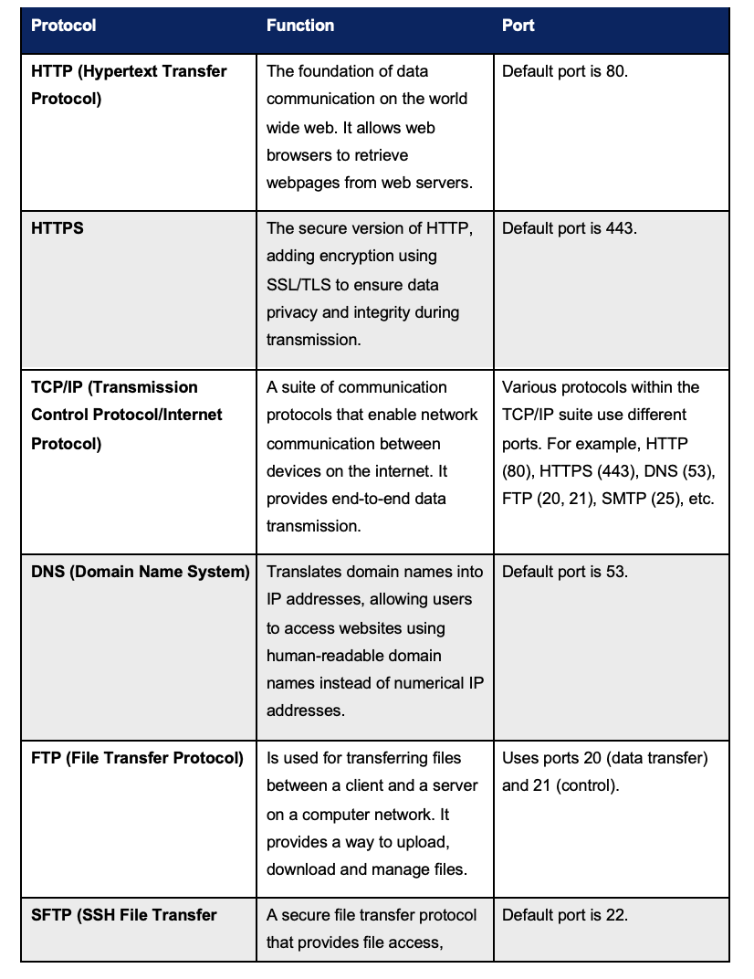

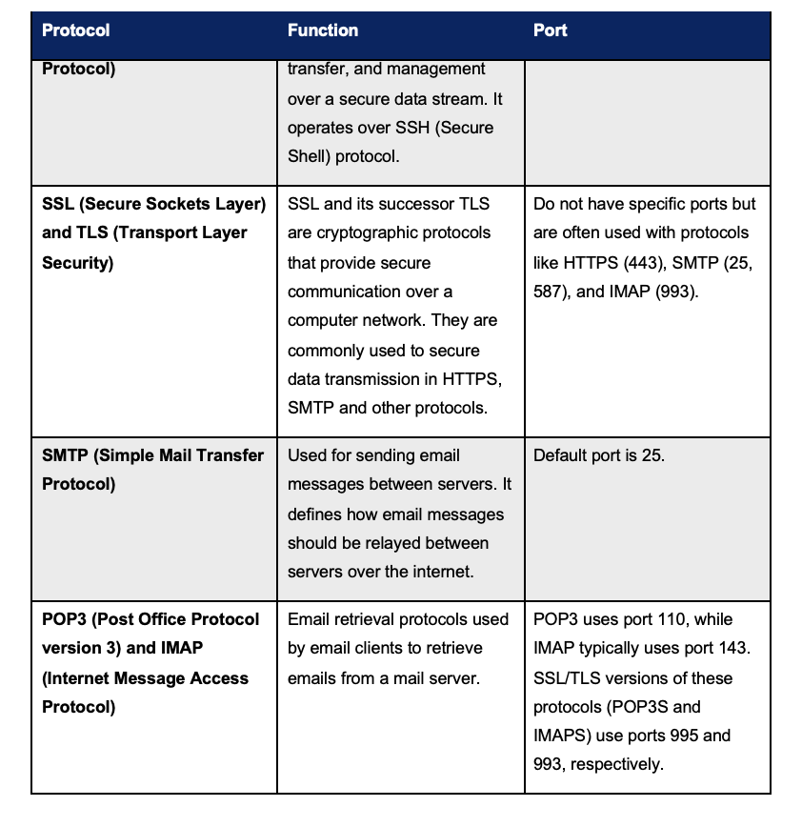

Explain the processes for securing the web

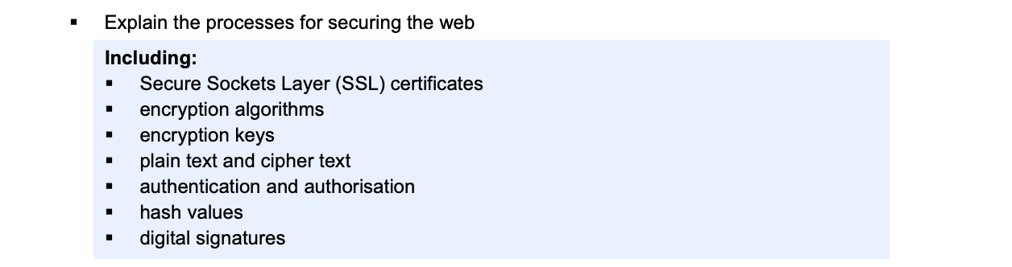

Securing the web is a complex process that involves a variety of mechanisms to ensure the confidentiality, integrity, and authenticity of data as it moves between users and servers. At the core of web security are concepts such as encryption, authentication, authorization, and digital signatures. These concepts work together to protect sensitive data and secure communications.

SSL Certificates
An SSL certificate is a digital certificate issued by a trusted third-party entity known as a Certificate Authority (CA). It verifies the identity of the website and its owner. The process works as follows:
- A website owner generates a certificate signing request (CSR), which includes the website’s public key and information about the site.
- The CA validates the website’s identity and issues an SSL certificate, binding the domain name to the public key.
- The web browser of any visitor to the site uses this certificate to confirm that they are communicating with the legitimate server.
The SSL certificate contains important information such as the public key, the issuer (CA), the domain name, and the expiration date. It allows the establishment of a secure connection between the client and the server by facilitating the exchange of encryption keys.

Encryption Algorithms
Encryption is the process of converting readable data (plain text) into an unreadable format (cipher text) to prevent unauthorized access. Encryption algorithms are mathematical formulas used to perform this conversion. There are two main types of encryption:
Symmetric Encryption: the same key is used to both encrypt and decrypt data. This method is fast and efficient for encrypting large amounts of data, but it has a major challenge: securely sharing the key between the sender and receiver.
Asymmetric Encryption: two different keys are used: a public key for encryption and a private key for decryption. The public key can be shared with anyone, while the private key must be kept secure. Asymmetric encryption solves the problem of key exchange but is computationally more expensive than symmetric encryption.
Keys Explained - https://www.youtube.com/watch?v=aWk1_pIYK4s&list=PLIFyRwBY_4bQvq5PuJASilkHSVGLZtceZ&index=3
Encryption Keys
Encryption keys are strings of bits used by encryption algorithms to lock (encrypt) and unlock (decrypt) data. The security of encrypted data depends on the key length and the complexity of the algorithm. Longer keys are harder to break using brute-force attacks, which makes them more secure.
A key exchange process is required to share encryption keys between client and server.
In web security, both symmetric and asymmetric keys are used:
- Symmetric keys: Typically used for bulk data encryption because of their speed.
- Asymmetric keys: Used for secure key exchange and digital signatures.
Plain Text and Cipher Text
- Plain text refers to the original, readable form of data that can be understood by humans or computers. For example, when a user enters their password on a website, it is initially in plain text.
- Cipher text is the scrambled, encrypted version of the plain text. This is what gets transmitted over the internet to protect the sensitive information. Even if an attacker intercepts the cipher text, they cannot decipher it without the appropriate decryption key.
For example, a message like "Hello" may be converted into cipher text as "A8c$7B2". Without the encryption key, the original message cannot be reconstructed.

Authentication
Authentication is the process of verifying the identity of a user or system. It ensures that only authorized parties can access a resource or service.
Authentication typically involves one or more of the following methods:
- Something you know (e.g., a password or PIN).
- Something you have (e.g., a smart card, token, or mobile phone).
- Something you are (e.g., a fingerprint, facial recognition, or other biometric data).
On the web, authentication often involves the use of usernames and passwords. However, more secure systems implement two-factor authentication (2FA), which combines two different types of credentials, such as a password (something you know) and a code sent to your phone (something you have).
In SSL/TLS, authentication is handled through the use of SSL certificates, which authenticate the identity of the server. Optionally, client certificates can be used to authenticate the client.

Authorization
Authorization comes after authentication and refers to the process of determining whether a user has permission to access a resource or perform a specific action. While authentication confirms identity, authorization confirms access rights.
For example, after logging into a web application, a user may be authenticated as a valid user, but they may not have permission to access administrative features or sensitive data. Authorization mechanisms are usually role-based, with different levels of access granted to different roles (e.g., user, admin, moderator).
Web applications implement authorization using access control mechanisms such as:
- Role-based access control (RBAC): Permissions are granted based on the user’s role within the system.
- OAuth: An open standard for access delegation, allowing users to grant third-party applications limited access to their resources without sharing credentials.

Hash Values
A hash function is a mathematical algorithm that takes an input (or "message") and produces a fixed-length string of characters, which is typically a hexadecimal number. This output is called a hash value or digest. Hash functions are used to ensure data integrity by verifying that a message has not been altered during transmission.
Hash values are often used in password hashing. When users create passwords, the password is hashed and stored in the server. When they log in, the server hashes the entered password and compares it to the stored hash. Hashing ensures that even if the password database is compromised, the actual passwords are not exposed.

Digital Signatures
A digital signature is a cryptographic method used to verify the authenticity and integrity of a message or document. It provides assurance that the message was created by the sender and was not altered during transmission.
The process of creating a digital signature involves:
- The sender generates a hash of the message.
- The sender encrypts the hash using their private key, creating the digital signature.
- The recipient uses the sender’s public key to decrypt the signature and verify the hash. If the hash matches the hash of the received message, the message is authentic.
Digital signatures rely on asymmetric encryption. They are commonly used in SSL certificates, where the CA’s digital signature is used to verify the certificate’s authenticity.
https://www.youtube.com/watch?v=pgqbCGly8LU&list=PLIFyRwBY_4bQvq5PuJASilkHSVGLZtceZ&index=10
Securing Data Transmission: Putting It All Together
When a user visits a secure website using HTTPS, several processes work together to ensure that the communication is secure:
- Handshake: The client and server initiate an SSL/TLS handshake. The server presents its SSL certificate, which contains the server’s public key.
- Authentication: The client verifies the certificate with the CA to ensure that the server is legitimate.
- Key Exchange: The client and server use asymmetric encryption (RSA or Diffie-Hellman) to securely exchange a symmetric session key.
- Encryption: Once the session key is exchanged, the client and server encrypt all communications using symmetric encryption (usually AES) for efficiency.
- Integrity and Authentication: The server may also use a digital signature to sign the data, and hash values (via HMAC) to ensure that the data has not been tampered with.
Investigate the effect of big data on web architecture

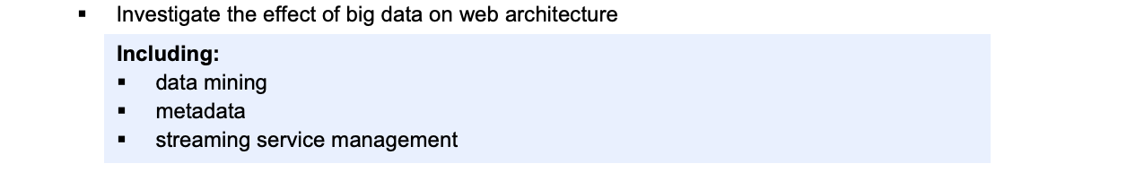

Big data refers to extremely large and complex data sets that are generated at high volume, velocity, and variety, making them difficult to process and analyse using traditional data management tools and techniques. The term encompasses not just the size of the data but also the challenges associated with managing, storing, and extracting meaningful insights from it.
The impact of big data on web architecture has been transformative, as the vast amounts of data generated by users, devices, and applications require new approaches to store, process, and analyse information.
Big data is typically characterised by four Vs:
- Volume: Refers to the massive amounts of data generated by various sources, such as social media, sensors, transactions, and devices. This volume often requires distributed storage and processing systems.
- Velocity: Describes the speed at which data is generated, collected, and processed. Real-time or near-real-time data processing is often necessary for applications such as financial markets or streaming services.
- Variety: Big data comes in many different forms, including structured data (like databases), semi-structured data (like XML or JSON files), and unstructured data (like text, images, videos).
- Veracity: The uncertainty or trustworthiness of the data.
Big data’s influence on web architecture requires designing scalable, efficient systems capable of processing large-scale data and providing real-time responses.

What is big Data - https://www.youtube.com/watch?v=bAyrObl7TYE
DataMining - https://www.youtube.com/watch?v=81bm2OsEzbg
Metadata - https://www.youtube.com/watch?v=L0vOg18ncWE

Data Mining
Data mining is the process of extracting valuable patterns and insights from large datasets. It plays a crucial role in big data by transforming raw data into meaningful information that can inform decision-making. In the context of web architecture, data mining affects how systems are designed, especially in terms of processing, storage, and retrieval of information.
Data Mining Tools and Techniques
Web architectures need to integrate with tools and techniques that support large-scale data mining. Some of these include:
- Cluster computing frameworks: Systems like Apache Hadoop and Apache Spark are built to handle big data workloads. These frameworks enable distributed data processing by dividing large datasets into smaller chunks, processing them across multiple nodes, and aggregating the results. This distributed approach is critical for scaling web architectures to accommodate massive data volumes.
- Machine learning algorithms: Algorithms like decision trees, neural networks, and clustering are used to identify patterns in data. These algorithms need scalable infrastructure that can support both training on large datasets and deploying models in real-time.
- Recommendation systems: Many web services, such as e-commerce and streaming platforms, use data mining techniques to build recommendation systems. These systems analyse user behaviour and preferences to suggest content or products, requiring robust data storage and retrieval systems capable of handling vast user data sets.
Real-Time Data Mining
Real-time data mining requires web architectures to process incoming data streams in real-time and provide instant insights or predictions. This requires low-latency, high-throughput systems. Event-driven architectures are commonly used in such scenarios, where microservices react to data events as they occur, allowing immediate processing and response.
Impact on Database Design
Web architectures must now support databases that can handle big data challenges, such as NoSQL databases like MongoDB or Cassandra. These databases can efficiently store and query large amounts of semi-structured and unstructured data while ensuring high availability and scalability. Unlike traditional relational databases, NoSQL databases can easily expand horizontally, allowing the web architecture to grow with the data.

Metadata

Metadata refers to data that describes other data. In the context of big data and web architecture, metadata management is critical for organising, searching, and retrieving data efficiently. Metadata helps make sense of large data sets by providing context, structure, and meaning to raw data.

Importance of Metadata
With vast quantities of data being collected, metadata becomes essential for understanding and categorizing data. Metadata provides information such as:
- Data source: Where the data came from.
- Data type: Whether it’s structured, semi-structured, or unstructured.
- Time stamp: When the data was collected or generated.
- Data ownership: Who created or owns the data.
- Access permissions: Who is allowed to access or modify the data.
Efficient metadata management allows for easier data discovery, ensuring that analysts or systems can find the data they need quickly and with minimal manual effort.

Metadata-Driven Architectures
Modern web architectures often leverage metadata-driven designs where systems automatically adapt based on metadata properties. For example, data lakes store vast amounts of raw data in its native format, with metadata being used to identify, classify, and query the data.
In a big data environment, metadata helps manage data lineage, ensuring that organisations can track the flow of data from its origin to its current form. This is critical for maintaining data integrity and for regulatory compliance (e.g., GDPR), as organisations need to know where their data is, who has accessed it, and how it has been modified.

Metadata in Distributed Systems
Distributed web architectures, such as those using microservices, need efficient metadata management systems to ensure that data is properly synchronised and accessible across different services. Without proper metadata management, maintaining consistency and coherence in a distributed system becomes exceedingly difficult.
Systems like Apache Kafka or Amazon Kinesis use metadata to manage event streams, ensuring that different microservices can subscribe to relevant events, process them, and store the resulting data in the appropriate systems.
Streaming Service Management

Data streaming refers to the continuous flow of data that is processed in real-time. With the increasing use of streaming services such as video platforms (Netflix, YouTube), financial services, and IoT applications, managing streaming data has become a key consideration in web architecture.

Real-Time Data Processing
- To handle streaming data efficiently, web architectures need to adopt frameworks and systems that support real-time data processing.
- Apache Kafka enables different services to produce and consume event data efficiently, ensuring low-latency, high-throughput data processing.
- Apache Flink and Apache Storm ensure that data can be processed as it arrives, making them ideal for real-time analytics, fraud detection, and recommendation systems.

Content Delivery Networks (CDNs)
For streaming services, especially video or multimedia, Content Delivery Networks (CDNs) are critical.
- CDNs distribute content across multiple geographically dispersed servers, allowing users to access content from a server that is physically closer to them, reducing latency and improving load times.
- CDNs handle the load balancing and caching of streaming data, ensuring that web architectures can scale to serve millions of users simultaneously without degradation in performance.

Scalability and Fault Tolerance
Web architectures managing streaming services must be designed for horizontal scalability. As user demand increases, the system must scale to accommodate higher loads without compromising performance. This often involves the use of containerisation technologies (e.g., Docker, Kubernetes) that allow microservices to scale independently based on demand.
To ensure reliability, fault tolerance mechanisms are embedded within the architecture. Distributed systems like Kafka and Flink provide mechanisms for automatic failover and data replication, ensuring that even if part of the system goes down, streaming services continue to function seamlessly.

